INSPIRING THE YOUTH OF JACKSON TO ACCOMPLISH THEIR GOALS AND DREAMS!
D2R day is designed to provide an opportunity for the youth of Jackson to explore their goals and dreams. Providing tips and resources for overcoming objections, from the people that have had the results that you are looking for. Take the first step by joining us for a day of fun.
Key Note Speaker:
Myeshia Jones
Miss Jackson County RoseQueen 2015
Free Lunch
Give a-ways and door prizes.
Special Guest Speakers!
Saturday July 9, 2016
9:30 am Registration
Event: 10:00 am – 3:00 pm
Baker College of Jackson Bldg 100
For Children 13 to 16 years of age
Name of Student: __________________________________________________
Age of Student: __________________
School: ______________________ Grade: ___________________
Physical Mailing Address: __________________________________________________________
Parent or Guardian First Name: _____________________________ Last Name: _____________________
Parent or Guardian’s Phone Number: ______________________________________
Alternative phone number: ________________________________
I understand that my child is being enrolled in the Dreams 2 Reality Day Workshop. I understand that this is a free event for my child and will provide transportation to and from the event. I understand that if my child does not behave appropriately, they will be dismissed from the program and I will be asked to pick them up early. I understand that this program is open to the first 100 students ages 13 to 16. If I am not one of the first 100, your name will be placed on a waiting list and you will be contacted if an opening becomes available.
I agree to all of the conditions stated above: Yes
Parent or Guardian’s signature: ________________________________________________
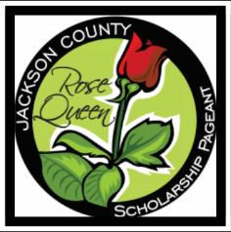 For questions please email jacksoncountyrosequeen@gmail.com
Or call 517-612-9678
Please return this completed form to: Miss Jackson County RoseQueen 393 Woodland Ave. Jackson MI 49203
Title Sponsor

