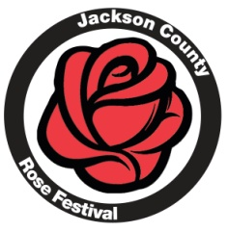
Rose Parade – June 4, 2017
Float Judging Information (11:30 – 12:30 pm)

Theme: Let’s Go To The Movies
Floats will be judged on six criteria: http://www.valleydecorating.com/howto.html
- Theme Compatibility http://www.wikihow.com/Build-a-Float
- General Design https://www.youtube.com/watch?v=bzfeO5kM3VU
- Use of Color http://www.paradefloatsuppliesnow.com/parade-float-kits
- Use of Materials
- Animation
- Special Effect
Each criteria will be scored on a scale from 1 to 5, with 5 being the highest. These criteria scores are summed to give a total score for the float. Entries are asked to decorate their float with the theme in mind. Anything that ties to the theme is fine. To score well in this area, they must have a design that relates to the theme. The rest of the criteria are self explanatory.
The following awards will be given:
Grand Champion = Highest total score
1st Runner Up = Second highest score
2nd Runner Up = Third highest score
Honorable Mention = Does not have to be the fourth highest score. This award will represent a business/organization which has obviously put a lot of time, effort and thought into their design and deserves an award for their overall efforts no matter how they compare to the other floats. However, they must still have a tie to the theme in their decorations.
The winners will be determined after scoring and tabulating all floats based on the above criteria. A trophy and float banner will be presented to each winning float prior to the start of the parade.
WEATHER: The parade is on unless it is lightening. The parade will go off at 1 pm through the rain. Only cancelled due to lightening
Questions contact: Volunteer Rose Parade Committee, email: roseparadepicnic@gmail.com
All scores from the judges are final and confidential.

