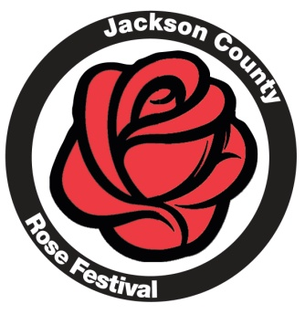
Rose Parade
Rose Parade Rules
Parade Theme: Everything’s Coming Up Roses

ALL parade entries MUST fill out and submit a Parade Entry Form!
- There will be no limit for parade entries. But all entries will be evaluated for acceptance based on use, entertainment value and connection to the Rose Festival theme. The Parade Committee reserves the right to refuse any entry. All entries will be accepted unless you are notified otherwise.
- The entry application must be received on or before May 27, 2016. Entries received after this date will be given consideration only after all other applications have been reviewed.
- All entries in the parade must be created with the intent to entertain through a float, band, an unusual display or performance or showing support of the Rose Parade theme in some manner. Entries merely advertising a business or service are asked to decorate with the theme in mind. Businesses may sponsor a musical entry or other entry types in the parade and receive appropriate recognition. All participants in the parade must be affiliated with a business, organization or group. Individual citizen walkers/bikers will not be allowed.
- For safety reasons, throwing of candy or any other items during the parade will NOT be permitted. Any violation of this rule will result in immediate removal from the parade. You may have walkers in the parade and they may HAND OUT candy along the parade route, but handing out literature, coupons, brochures, flyers, or anything of an advertising nature is strictly prohibited.
- All residential parade entries that want to include dogs in the parade must have liability insurance, and MUST provide a certificate of insurance prior to the parade listing the Jackson County Rose Festival Inc. as additional insured on parade day. If said certificate is not presented, dogs are not permitted in the parade.
- Trucks and vans will be selected on an individual basis according to the rules mentioned in Rule #3.
- Floats cannot exceed a height of 14 feet.
- Consumption of alcoholic beverages in the staging area or on the parade route is strictly prohibited. Any violation of this rule will be cause for immediate removal from the parade.
- All parade participants are required to conduct themselves in such a manner so as not to infringe on the rights of those people living in and along the staging areas and parade route.
- Each unit is required to remove any trash created by it’s entry in the staging area before the parade commences.
- The de-staging area is located at the Middle School at Parkside. The only vehicles allowed in the parking lot are vehicles IN the parade with the exception of buses for bands, trailers for dismantling floats and the like. Due to the large number of walkers in the parade, vehicles picking up walkers WILL NOT be allowed in this parking lot from any entrance point, so please coordinate pick up accordingly. Suggestion would be to have walkers go directly to Ella Sharp Park and meet up with transportation there.
- Please plan to come over to the Picnic in the Park and enjoy the chicken BBQ and kids activities
If you have questions, contact the Rose Parade Committee at roseparadepicnic@gmail.com.

